**5.3**

#include <iostream>

#include <iomanip>

using namespace std;

int main()

{

// convert kilogram to pound

const double KiloToPound = 2.2;

cout << "Kilograms" << setw(10) << "Pounds\n";

//display kilograms converted to pounds

for (int kilo = 1; kilo < 200; kilo++)

{

double pound = kilo * KiloToPound;

cout << left << setw(12) << kilo << pound << endl;

}

system("pause");

return 0;

}

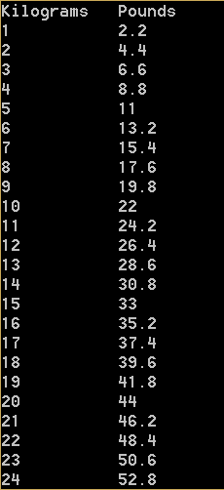 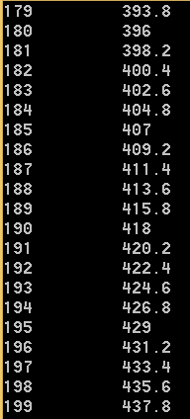

**5.9**

#include <iostream>

#include <iomanip>

using namespace std;

int main()

{

// computes and displays tuition in ten years

double tuition = 10000;

double sum = 0;

for (int year = 1; year <= 10; year++)

{

tuition *= 1.05;

}

cout << "Your tuition in ten years is $" << fixed << setprecision(2) << tuition << endl;

// computes and displays total of tuition for 4 years after 10 years from now

for (int year = 10; year <= 13; year++)

{

sum += tuition;

tuition *= 1.05;

}

cout << "The total cost of four years' worth of tuition\nstarting ten years from now is $"

<< fixed << setprecision(2) << sum << endl;

system("pause");

return 0;

}

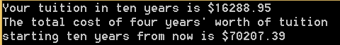

**5.27**

#include <iostream>

#include <iomanip>

using namespace std;

int main()

{

double PI;

double in = 0;

cout << left << setw(10) << "i" << "PI\n";

// to show the results of PI for i according to formula

for (int i = 1; i <= 100000; i++)

{

in += pow(-1, (i + 1)) / (2 * i - 1);

if (i % 10000 == 0)

{

PI = 4 * in;

cout << left << setw(10) << i << PI << endl;

}

}

system("pause");

return 0;

}

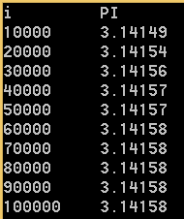

**5.47**

#include <iostream>

using namespace std;

int main()

{

// prompt user to enter ten numbers

cout << "Enter ten numbers (with spaces in between): \n";

double num;

double sum = 0;

double power = 0;

// to calculate inside the mean and deviation

for (int i = 1; i <= 10; i++)

{

cin >> num;

sum += num;

power += pow(num, 2);

}

// display results for mean and deviation

double mean = sum / 10;

cout << "The mean is " << mean << endl;

double deviation = sqrt((power - ((pow(sum, 2))/10)) / 9);

cout << "The standard deviation is " << deviation << endl;

system("pause");

return 0;

}

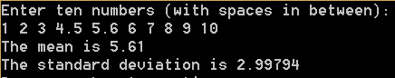

**6.5**

#include <iostream>

using namespace std;

// function to display three numbers in increasing order

void displaySortedNumbers(double num1, double num2, double num3)

{

if (num1 < num2 && num1 < num3)

{

if (num2 < num3)

cout << num1 << " " << num2 << " " << num3 << endl;

else

cout << num1 << " " << num3 << " " << num2 << endl;

}

else if (num2 < num3 && num2 < num1)

{

if (num3 < num1)

cout << num2 << " " << num3 << " " << num1 << endl;

else

cout << num2 << " " << num1 << " " << num3 << endl;

}

else if (num3 < num1 && num3 < num2)

{

if (num1 < num2)

cout << num3 << " " << num1 << " " << num2 << endl;

else

cout << num3 << " " << num2 << " " << num1 << endl;

}

}

// prompt the user to enter three numbers and invokes the function above

int main()

{

cout << "Enter three numbers:\n";

double a, b, c;

cin >> a >> b >> c;

displaySortedNumbers(a, b, c);

system("pause");

return 0;

}

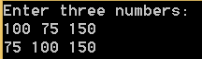

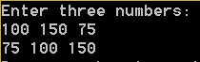

**6.13**

#include <iostream>

#include <iomanip>

using namespace std;

// function for returning m(i) for a given i

double mi(int i)

{

double sum = 0;

for (int k = 1; k <= i; k++)

sum += pow(-1, (k + 1)) / (2 * k - 1);

return 4 * sum;

}

// test program that uses the function above

int main()

{

cout << left << setw(20) << "i" << "m(i)\n";

for (int k = 1; k < 902; k += 100)

{

cout << left << setw(20) << k << fixed << setprecision(4) << mi(k) << endl;

}

system("pause");

return 0;

}

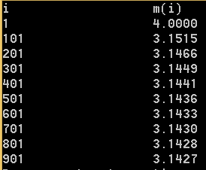

**6.31**

#include <iostream>

using namespace std;

// function for swapping two numbers

void swap(double& x, double& y)

{

double temp;

temp = x;

x = y;

y = temp;

}

// function to sort the numbers in increasing order

void sort(double& num1, double& num2, double& num3)

{

if (num1 > num2)

{

swap(num1, num2);

if (num2 > num3)

{

swap(num2, num3);

if (num1 > num2)

swap(num1, num2);

}

}

else if (num2 > num3)

{

swap(num2, num3);

if (num1 > num2)

swap(num1, num2);

}

}

// prompt user to enter three numbers and display them in sorted order

int main()

{

// prompt the user to enter three numbers

cout << "Enter three numbers (with spaces in between):\n";

double a, b, c;

cin >> a >> b >> c;

// display the numbers in sorted order

sort(a, b, c);

cout << a << " " << b << " " << c << endl;

system("pause");

return 0;

}

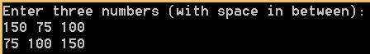



**6.32**

#include <iostream>

using namespace std;

// write a function to calculate the discriminant and the roots

void solveQuadraticEquation(double a, double b, double c,

double& discriminant, double& r1, double& r2)

{

discriminant = pow(b, 2) - 4 * a * c;

if (discriminant >= 0)

{

r1 = (-b + sqrt(discriminant)) / (2 * a);

r2 = (-b - sqrt(discriminant)) / (2 * a);

}

}

int main()

{

// prompt user to enter three numbers

cout << "Enter a, b ,c (with spaces in between):\n";

double ma, mb, mc;

double mdiscriminant, mr1, mr2;

cin >> ma >> mb >> mc;

// display results based on the discriminant

solveQuadraticEquation(ma, mb, mc, mdiscriminant, mr1, mr2);

if (mr1 == mr2 && mdiscriminant == 0)

cout << "The root is " << mr1 << endl;

else if (mr1 != mr2 && mdiscriminant > 0)

cout << "There roots are " << mr1 << " and " << mr2 << endl;

else

cout << "The equation has no roots.\n";

system("pause");

return 0;

}

